The Blogging Cookbook for College ESL Teachers

By Nicholas Walker and Helen Hefter
2016
(Last updated: April 9, 2018)

This work is licensed under a Creative Commons Attribution-ShareAlike 2.5 Canada License.

To view a copy of this license, visit http://creativecommons.org/licenses/by-sa/2.5/ca/ or send a letter to Creative Commons, PO Box 1866, Mountain View, CA 94042, USA.

You are free to:
- Share — copy and redistribute the material in any medium or format
- Adapt — remix, transform, and build upon the material
- for any purpose, even commercially.

The licensor cannot revoke these freedoms as long as you follow the license terms.

Under the following terms:
- Attribution — You must give appropriate credit, provide a link to the license, and indicate if changes were made. You may do so in any reasonable manner, but not in any way that suggests the licensor endorses you or your use.

- ShareAlike — If you remix, transform, or build upon the material, you must distribute your contributions under the same license as the original.

Notices:
- You do not have to comply with the license for elements of the material in the public domain or where your use is permitted by an applicable exception or limitation.
- No warranties are given. The license may not give you all of the permissions necessary for your intended use. For example, other rights such as publicity, privacy, or moral rights may limit how you use the material.

Hypertext Table of Contents
Getting Started
- About
- How to Create a Blog on Blogger.com
- Some Important Buttons and Settings
- Blogger Toolbars
- Basic HTML tags
- Resources for Learning More about Blogging and HTML
Adding Content and Features
- Add Tables with Verb Paradigms
- Add a Field of Study Glossary
- Embed a Video from YouTube
- Add Copyright-free Images from WikiMedia Commons
- Get Your Own Domain Name for Your blog
Adding Apps
- Add an MP3 Player
- Add an ESL Grammar Checker
- Add a B-block Vocabulary Checker
- Add a Speech Recognition Enabled Pronunciation Checker
- Add a Random Error Generator and Checker
- Add a Text-to-Speech Pronunciation App
- Add an MP3 voice recorder

About
The Blogging Cookbook for College ESL Teachers is intended to be self-explanatory. By following the directions, you will be able to create a web-log website (blog) that could prove useful and profitable to you. The examples are all relevant to ESL/EFL and will generate traffic, which will attract readers, advertisers and revenue to your blog. The principle goal of this cookbook, however, is to provide you with the confidence and momentum you’ll need to continue blogging and learning HTML, a basic web-programming language used extensively on the internet.
Below, you will find the steps to follow to produce a 13-post blog of your own. The first three sections will simply introduce you to a free blogging platform called Blogger.com. Blogger is a Google property. It is free and easy to use. After a year of blogging, Blogger will offer to integrate AdSense advertisements into your blog, which will allow you to start making money from ads. (Remember that ads pay for content, so if you see an ad that interests you on someone else’s blog, click it. It will send the blog writer a small commission.) College students are usually chronically hard-up, so the fact that blogs can generate income is something worth mentioning to students. The next section is merely an illustration of the common HTML tags. The remaining sections will provide you with a number of adaptable mini-projects to include in your blog. Finally, the last section lists some resources that will help you learn more about HTML and blogging with students.
All of the mini-projects in this cookbook use HTML rather than the what-you-see-is-what-you-get (WYSIWYG) compose-mode of Blogger. The reason for this choice is to provide you with HTML resources that you can use elsewhere, like Wordpress, Moodle, email, or any website that allows you to use HTML code. Also, I have found that simply by looking at HTML code you can learn a fair bit of HTML programming without having to take a course or rely on programmers. Basic HTML is pretty obvious: <b> means bold, <i> means italics, <strike> means strikethrough, <br> means break, etc. Take the time to look at the tags. You will get the hang of it very quickly.
Remember that you are free to share the code, text, and images in this Blogging Cookbook for College ESL Teachers with your students and colleagues. You are also free to reuse and adapt any part of this document provided that you credit us, the original authors, Nicholas Walker and Helen Hefter. We also ask (but cannot insist) that you retain the links in the various mini-projects to our websites: VirtualWritingTutor.com, FieldRelated.com, BokomaruPublications.com, and Actively-Engaged-Online.blogspot.com. These links send a weak signal to Google and Bing to rank our websites a little higher in their search results. That helps us get our message out about our projects.
You can add your name as co-author to your adapted or expanded version of this document and even charge money for it, but you must retain the Sharealike 2.5 license on derivations. For example, you may want to add instructions for creating an account on Wordpress.com or Tumblr.com. Please do. Just add your name under our names on the first page. Remember that you can change the cookbook and pass it on, but you cannot prevent others from further adapting and expanding this document, too. Sound fair?
In any case, we hope you find The Blogging Cookbook for College ESL Teachers useful to you and your students.
Nicholas Walker
Nicholas.Walker@CollegeAhuntsic.qc.ca

Helen Hefter
HelenHefter@hotmail.com

August 15, 2016

How to Create a Blog on Blogger.com

Step 1
The first step to creating your own blog for language learning is to go to Blogger.com. You will need to create an account if you don't have a Gmail account already. It is easy and takes seconds.
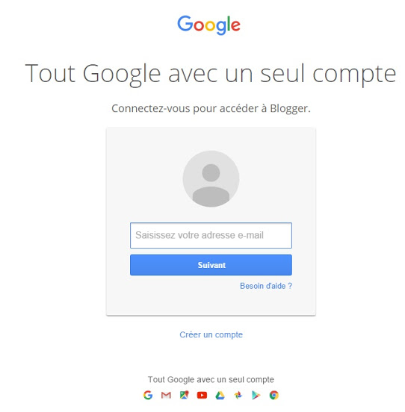

Step 2
The next step is a little more complicated. You will need to create a title and address for your blog. The title should be related to your field of study or the thing that you expect to be writing about most. If you are not sure what topic you want to blog about, consider creating a title and address related to your name. If your name is "Helen" and your field of study is “English as a Second Language,” name your blog ESL with Helen (title) at esl-with-helen.blogspot.com (address). You will also have to choose a template. Choose something simple because this part is easy to change later. (Warning: I have encountered a bug that causes this step to fail if your title is too long. Try simplifying it to one word to get passed this step, and then revise your title in the settings menu later.)
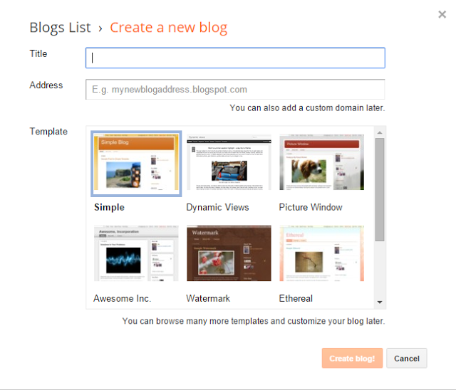

Step 3
Once you have created your blog title and address, click "New post" under the word "My blogs" on the left. If your blog is in another language you can change the language setting here by clicking the "cog" icon in the top right.
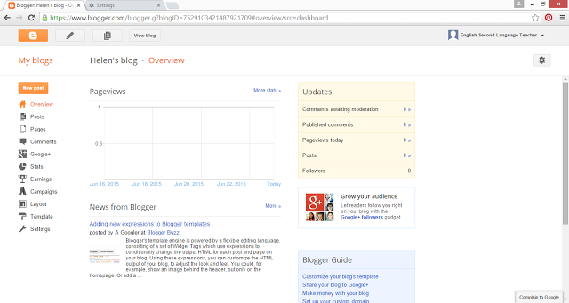

Step 4
When you click "New post" you will see a blank page. Give your blog post a title, like "About Me" and write something about who you are and what you do. Click "Save" and "Publish" on the right and click "View blog" on the left. Now, you are a blogger.

Step 5
You can leave your first blog post as it is, but serious writers look for feedback on their writing. Copy (CTRL +A, CTRL +C) a blog post and paste (CTRL +V) it into the VirtualWritingTutor.com and click “Check spelling” and "Check grammar" to see if it can detect any errors. Students find this step reassuring. It forms a simple revision strategy that they can use anytime, day or night, in the context of an ESL course or long after the course has finished.
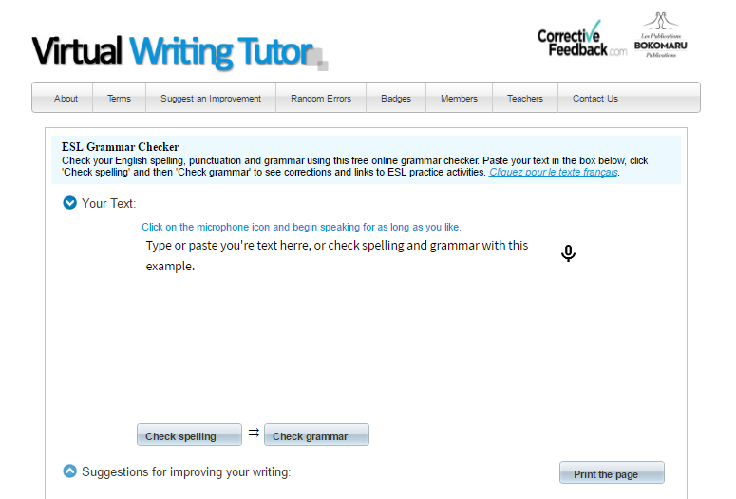

Step 6
Simply edit your post, make the necessary corrections, and click "Update." Now, you are ready to promote your blog. Why not join us at https://www.facebook.com/groups/learn.English.by.blogging and share your first blog post. The other members of this group would love to meet you.
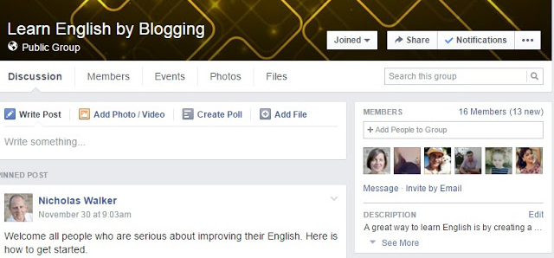

Step 7
Help your students start blogging by adding these steps to your blog. Copy and paste the HTML code below into the HTML mode of a new blog post and publish it with a title of your own.
<h2 style="clear: both; text-align: left;">
How to Create a Blog on Blogger</h2>
<h3>
Step 1</h3>
<div>
The first step to creating your own blog for language learning is to go to <a href="http://blogger.com/" target="_blank">Blogger.com</a>. You will need to create an account if you don't have a Gmail account already. It is easy and takes seconds.&nbsp;</div>
<div>

</div>
<div>
<div class="separator" style="clear: both; text-align: center;">
<a href="http://2.bp.blogspot.com/-BVzdNJuGnJE/VmsL1TqnHbI/AAAAAAAABjE/lv74rxQpfjo/s1600/blogger1.jpg" imageanchor="1" style="margin-left: 1em; margin-right: 1em;"><img border="0" height="616" src="https://2.bp.blogspot.com/-BVzdNJuGnJE/VmsL1TqnHbI/AAAAAAAABjE/lv74rxQpfjo/s640/blogger1.jpg" width="640" /></a></div>
<h3>
Step 2</h3>
The next step is a little more complicated. You will need to create a title and address for your blog. The title should be related to your field of study or the thing that you expect to be writing about most. If you are not sure what topic you want to blog about, consider creating a title and address related to your name. If your name is "Helen" and your field of study is “English as a Second Language,” name your blog <i>ESL with Helen</i> (title) at <i>esl-with-helen.blogspot.com</i> (address). You will also have to choose a template. Choose something simple because this part is easy to change later.&nbsp;</div>
<div class="separator" style="clear: both; text-align: center;">
<a href="http://3.bp.blogspot.com/-jrFlcuGdnA8/VmsLAPXlf4I/AAAAAAAABig/3LnSOlAuVKg/s1600/2015-06-24%2B13_30_21-Blogger_%2BBlogger%2BDashboard.png" imageanchor="1" style="margin-left: 1em; margin-right: 1em;"><img border="0" height="547" src="https://3.bp.blogspot.com/-jrFlcuGdnA8/VmsLAPXlf4I/AAAAAAAABig/3LnSOlAuVKg/s640/2015-06-24%2B13_30_21-Blogger_%2BBlogger%2BDashboard.png" width="640" /></a></div>
<div class="separator" style="clear: both; text-align: center;">

</div>
<h3>
Step 3</h3>
Once you have created your blog title and address, click "New post" under the word "My blogs" on the left. If your blog is in another language you can change the language setting here by clicking the "cog" icon in the top right.

<div class="separator" style="clear: both; text-align: center;">
<a href="http://1.bp.blogspot.com/-225L07EdCME/VmsLDUihmSI/AAAAAAAABis/RaGkxwquxTI/s1600/2015-06-24%2B13_37_29-Blogger_%2BHelen%2527s%2Bblog%2B-%2BOverview.png" imageanchor="1" style="margin-left: 1em; margin-right: 1em;"><img border="0" height="340" src="https://1.bp.blogspot.com/-225L07EdCME/VmsLDUihmSI/AAAAAAAABis/RaGkxwquxTI/s640/2015-06-24%2B13_37_29-Blogger_%2BHelen%2527s%2Bblog%2B-%2BOverview.png" width="640" /></a></div>

<h3>
Step 4</h3>
<div class="separator" style="clear: both; text-align: left;">
When you click "New post" you will see a blank page. Give your blog post a title, like "About Me" and write something about who you are and what you do. &nbsp;Click "Save" and "Publish" on the right and click "View blog" on the left. Now, you are a blogger.&nbsp;</div>
<div class="separator" style="clear: both; text-align: center;">
<a href="http://4.bp.blogspot.com/-SONr3T2mBxU/VmsLDTKhhsI/AAAAAAAABiw/I9e7w8vnLns/s1600/2015-06-24%2B13_38_09-Blogger_%2BHelen%2527s%2Bblog%2B-%2BCreate%2Bpost.png" imageanchor="1" style="margin-left: 1em; margin-right: 1em;"><img border="0" height="340" src="https://4.bp.blogspot.com/-SONr3T2mBxU/VmsLDTKhhsI/AAAAAAAABiw/I9e7w8vnLns/s640/2015-06-24%2B13_38_09-Blogger_%2BHelen%2527s%2Bblog%2B-%2BCreate%2Bpost.png" width="640" /></a></div>
<h3>
Step 5</h3>
<div class="separator" style="clear: both; text-align: left;">
You can leave your first blog post as it is, but serious writers look for feedback on their writing. Copy your first blog post and paste it into the <a href="http://virtualwritingtutor.com/">VirtualWritingTutor.com</a>&nbsp;and click "Check grammar" to see if it can detect any errors. If there are errors in your text, the&nbsp;<a href="http://virtualwritingtutor.com/">VirtualWritingTutor</a>&nbsp;will show you how to correct them. &nbsp;&nbsp;</div>
<div class="separator" style="clear: both; text-align: center;">
</div>

<div class="separator" style="clear: both; text-align: center;">
</div>
<div class="separator" style="clear: both; text-align: center;">
<a href="https://3.bp.blogspot.com/-e5YIQatpMUY/V7B342hi6lI/AAAAAAAABzQ/c1_lrMqf7UYV4ujE08UgOd8CXi8FlN1DwCLcB/s1600/VWT.png" imageanchor="1" style="margin-left: 1em; margin-right: 1em;"><img border="0" height="430" src="https://3.bp.blogspot.com/-e5YIQatpMUY/V7B342hi6lI/AAAAAAAABzQ/c1_lrMqf7UYV4ujE08UgOd8CXi8FlN1DwCLcB/s640/VWT.png" width="640" /></a></div>

<h3>
Step 6</h3>
<div class="separator" style="clear: both; text-align: left;">
Simply edit your post, make the necessary corrections, and click "Update." Now, you are ready to promote your blog. Why not join us a <a href="https://www.facebook.com/groups/learn.English.by.blogging">https://www.facebook.com/groups/learn.English.by.blogging</a>&nbsp;and share your first blog post. The other members of this group would love to meet you and help you improve your writing.&nbsp;</div>
<div class="separator" style="clear: both; text-align: center;">

</div>
<div class="separator" style="clear: both; text-align: center;">
<a href="http://4.bp.blogspot.com/-vaS4NXKbKUI/VmsWHaPdPpI/AAAAAAAABjY/kJTa9uR2d-E/s1600/blogger3.jpg" imageanchor="1" style="margin-left: 1em; margin-right: 1em;"><img border="0" height="428" src="https://4.bp.blogspot.com/-vaS4NXKbKUI/VmsWHaPdPpI/AAAAAAAABjY/kJTa9uR2d-E/s640/blogger3.jpg" width="640" /></a></div>
<div class="separator" style="clear: both; text-align: center;">

</div>
<div class="separator" style="clear: both; text-align: center;">
</div>

<div style="text-align: center;">Find out more about <a href="http://www.bokomarupublications.com/products.html" target="_blank">blogging and digital literacy in ESL</a>.</div>

Some Important Buttons and Settings
Familiarize yourself with these buttons and settings. The Compose and HTML toolbars are explained on the next page.
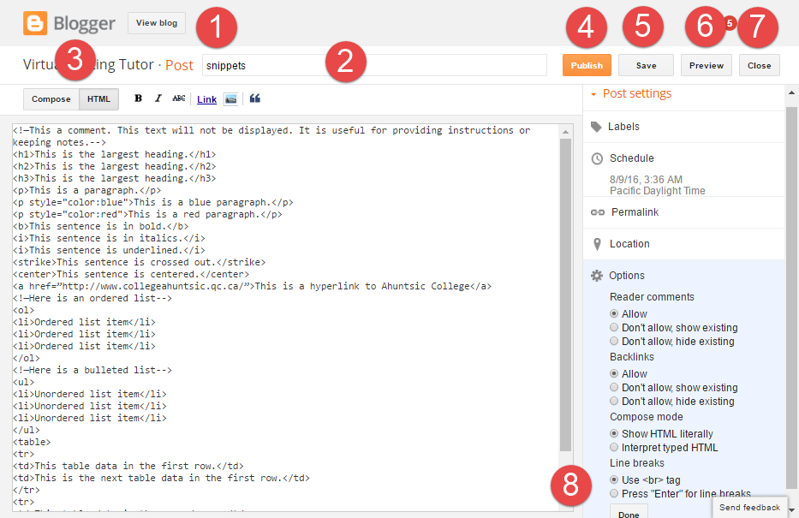
- Click “View blog” to see what the world sees. Note that Blogger.com is where you write your blog, but Blogspot.com is where your blog is published. Think of it like this: Blogger is the oven where you cook your food; Blogspot is the table where your food is served.
- Type a title here. Make sure to provide a meaningful title for each blogpost. The Google search engine uses webpage titles in its index. Without a title, it will be impossible for people to find your blog using a search engine. Titles, headings, and image captions contribute significantly to search engine optimization (SEO).
- Switch from “Compose” mode to “HTML” mode here. Compose mode is easier to use with its more extensive toolbar and WYSIWYG view. HTML mode gives you more control but a more limited toolbar.
- “Publish” adds the post you are working on to your blog. You don’t have to publish it. You can save it and publish it later, or you can unpublish it if you want to hide a blog post from the world.
- “Save” saves what you are working on. It does not publish the post.
- “Preview” will show you how your post will look without publishing it. Preview does not always render dynamic content well. If in doubt, publish and unpublish a post to see how it will really look.
- “Close” allows you to return to your list of blog posts. Save before you close.
- Every time you want to insert a line break, you can insist that <br> is used, or you set it so simply hitting the Enter key adds a line break. Most people prefer the second option since it involves less typing and makes HTML mode more like Compose mode in this regard.

Blogger Toolbars

HTML Toolbar
Here is the HTML Toolbar with numbers. The corresponding numbers below give the name of the effect and the tags each button inserts into the HTML code on the page.
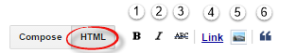
- Bold <b></b>
- Italics <i></i>
- Strikethrough <strike></strike>
- Hyperlink <a href=”www.somewebsiteaddress.com”>the blue underlined text to be displayed</a>
- Image <img src=” www.somewebsiteaddress.com/imagefilename.png” width=”200” height=”100” />
- Blockquote (indent) <blockquote></blockquote>

WYSIWYG Compose Toolbar
Here is the what-you-see-is-what-you-get Compose Toolbar with numbers. The corresponding numbers below give the name of the effect and the tags (if applicable) each button inserts into the HTML code on the page.
- Undo (CTRL + Z)
- Redo (CTRL + Y)
- Font selector <span style="font-family: Georgia, Times New Roman, serif;"></span>
- Font size selector <span style="font-size: large;"></span>
- Style selector (normal, heading 1, heading 2, heading 3)
- Bold <b></b>
- Italics <i></i>
- Underline <u></u>
- Strikethrough <strike></strike>
- Font colour <span style="color: red;">Text in red.</span>
- Highlight <span style="background-color: yellow;"></span>
- Hyperlink <a href=”www.somewebsiteaddress.com”>the blue underlined text to be displayed</a>
- Image <img src=” www.somewebsiteaddress.com/imagefilename.png” width=”200” height=”100” />
- Youtube video embed <iframe src="https://www.youtube.com/embed/wMFHPG2uqcY" ></iframe>
- Jump break separator to insert a “Read more…” link <div class="separator" style="clear: both;">
- Align text (left, right, center) <div style="text-align: left;"></div>
- Numbered list <ol><li></li></ol>
- Bulleted list <ul><li></li></ul>
- Blockquote (indent) <blockquote></blockquote>
- Remove text formatting
- Spell check

Basic HTML tags
Copy the html code in the box below and paste it into the HTML editor of a new blog post. Give your blog post a title and publish it to see how the browser interprets the HTML code.
Take the time to study the HTML tags and their effect on how text is displayed. Experiment. Blogger will tell you if you have made a mistake and how to fix it. Remember that all tags—with only a couple of exceptions—should have a closing tag (example: <p> </p>).
<!—This a comment. This text will not be displayed. It is useful for providing instructions or keeping notes.-->
<h1>This is the largest heading.</h1>
<h2>This is the largest heading.</h2>
<h3>This is the largest heading.</h3>
<p>This is a paragraph.</p>
<br><br><br> There are three line breaks before this sentence.
<p style="color:blue">This is a blue paragraph.</p>
<p style="color:red">This is a red paragraph.</p>
<span style="background-color: yellow;">This sentence is highlighted in yellow.</span>
<blockquote>This sentence is indented.</blockquote>
<b>This sentence is in bold.</b>
<i>This sentence is in italics.</i>
<u>This sentence is underlined.</u>
<strike>This sentence is crossed out.</strike>
<center>This sentence is centered.</center>
<div style="text-align: center;">This sentence is also centered but with a div tag and a style attribute instead.</div>
<a href="http://www.collegeahuntsic.qc.ca/">This is a hyperlink to Ahuntsic College</a>
<!—Here is an ordered list-->
<ol>
<li>Ordered list item 1</li>
<li>Ordered list item 2 </li>
<li>Ordered list item 3</li>
</ol>
<!—Here is a bulleted list-->
<ul>
<li>Unordered list item 1 </li>
<li>Unordered list item 2 </li>
<li>Unordered list item 3</li>
</ul>
<table>
<tr>
<td>This table data in the first row.</td>
<td>This is the next table data in the first row.</td>
</tr>
<tr>
<td>This table data in the second row.</td>
<td>This is the next table data in the second row.</td>
<tr>
</table>
<center>Find out how you can add digital literacy training to your CEGEP ESL course with a textbook from <a href="http://BokomaruPublications.com">Bokomaru Publications</a>.</center>

Tables with Verb Paradigms
Copy the html code in the box below and paste it into the HTML editor of a new blog post. Give your blog post a title and publish it to see how the browser interprets the HTML code. Note that the font size of the code has been reduced to fit this page.
<b><div style="text-align: center;">Correction Help</div></b>
<br> <br>

<b>VERB FORM: go/goes</b>
<br><i>RULE:</i> For events that always repeat, use the Simple Present.
<br>To go (Present Simple)<br /> <br /><table border="1" width="100%"><tbody> <tr> <td width="33%" valign="top">PERSON<br /> </td> <td width="33%" valign="top">SINGULAR<br /> </td> <td width="33%" valign="top">PLURAL<br /> </td> </tr> <tr> <td width="33%" valign="top">1st person<br /> </td> <td width="33%" valign="top">I go
</td> <td width="33%" valign="top">We go
</td> </tr> <tr> <td width="33%" valign="top">2nd person<br /> </td> <td width="33%" valign="top">You go
</td> <td width="33%" valign="top">You go
</td> </tr> <tr> <td width="33%" valign="top">3rd person<br /> </td> <td width="33%" valign="top">He goes, she goes, it goes
</td> <td width="33%" valign="top">They go
</td> </tr></tbody></table>
<br>
<br>
<b>VERB FORM: am/is/are going</b>
<br><i>RULE:</i> To talk about an event in progress, use the Present Progressive.
<br>To go (Present Progressive)<br /> <br />
<table border="1" width="100%"><tbody> <tr>
<td width="33%" valign="top">PERSON<br /> </td>
<td width="33%" valign="top">SINGULAR<br /> </td>
<td width="33%" valign="top">PLURAL<br /> </td> </tr> <tr>
<td width="33%" valign="top">1st person<br /> </td>
<td width="33%" valign="top">I am going </td>
<td width="33%" valign="top">We are going </td> </tr> <tr>
<td width="33%" valign="top">2nd person<br /> </td>
<td width="33%" valign="top">You are going </td>
<td width="33%" valign="top">You have gone </td> </tr> <tr>
<td width="33%" valign="top">3rd person<br /> </td>
<td width="33%" valign="top">He is going, she is going, it is going </td>
<td width="33%" valign="top">They are going </td> </tr></tbody></table>

<br> <br>
<b>VERB FORM: have gone/haven't gone</b>
<br><i>RULE:</i> To talk about a recent experience, use the Present Perfect.
<br>To go (Present Perfect)<br /> <br />
<table border="1" width="100%"><tbody> <tr>
<td width="33%" valign="top">PERSON<br /> </td>
<td width="33%" valign="top">SINGULAR<br /> </td>
<td width="33%" valign="top">PLURAL<br /> </td> </tr> <tr>
<td width="33%" valign="top">1st person<br /> </td>
<td width="33%" valign="top">I have gone </td>
<td width="33%" valign="top">We have gone </td> </tr> <tr>
<td width="33%" valign="top">2nd person<br /> </td>
<td width="33%" valign="top">You have gone </td>
<td width="33%" valign="top">You have gone </td> </tr> <tr>
<td width="33%" valign="top">3rd person<br /> </td>
<td width="33%" valign="top">He has gone, she has gone, it has gone </td>
<td width="33%" valign="top">They have gone </td> </tr></tbody></table>
<br> <br>
<br>To go (Present Perfect Negative)<br /> <br />
<table border="1" width="100%"><tbody> <tr>
<td width="33%" valign="top">PERSON<br /> </td>
<td width="33%" valign="top">SINGULAR<br /> </td>
<td width="33%" valign="top">PLURAL<br /> </td> </tr> <tr>
<td width="33%" valign="top">1st person<br /> </td>
<td width="33%" valign="top">I haven't gone </td>
<td width="33%" valign="top">We haven't gone </td> </tr> <tr>
<td width="33%" valign="top">2nd person<br /> </td>
<td width="33%" valign="top">You haven't gone </td>
<td width="33%" valign="top">You haven't gone </td> </tr> <tr>
<td width="33%" valign="top">3rd person<br /> </td>
<td width="33%" valign="top">He hasn't gone, she hasn't gone, it hasn't gone </td>
<td width="33%" valign="top">They haven't gone </td> </tr></tbody></table>
<br> <br>
<b>VERB FORM: went/didn't go</b>
<br><i>RULE:</i> To talk about a past event, use the Simple Past.
<br>To go (Simple Past)<br /> <br />
<table border="1" width="100%"><tbody> <tr>
<td width="33%" valign="top">PERSON<br /> </td>
<td width="33%" valign="top">SINGULAR<br /> </td>
<td width="33%" valign="top">PLURAL<br /> </td> </tr> <tr>
<td width="33%" valign="top">1st person<br /> </td>
<td width="33%" valign="top">I went </td>
<td width="33%" valign="top">We went </td> </tr> <tr>
<td width="33%" valign="top">2nd person<br /> </td>
<td width="33%" valign="top">You went </td>
<td width="33%" valign="top">You went </td> </tr> <tr>
<td width="33%" valign="top">3rd person<br /> </td>
<td width="33%" valign="top">He went, she went, it went </td>
<td width="33%" valign="top">They went </td> </tr></tbody></table>
<br> <br>
<br>To go (Simple Past Negative)<br /> <br />
<table border="1" width="100%"><tbody> <tr>
<td width="33%" valign="top">PERSON<br /> </td>
<td width="33%" valign="top">SINGULAR<br /> </td>
<td width="33%" valign="top">PLURAL<br /> </td> </tr> <tr>
<td width="33%" valign="top">1st person<br /> </td>
<td width="33%" valign="top">I didn't go </td>
<td width="33%" valign="top">We didn't go </td> </tr> <tr>
<td width="33%" valign="top">2nd person<br /> </td>
<td width="33%" valign="top">You didn't go </td>
<td width="33%" valign="top">You didn't go </td> </tr> <tr>
<td width="33%" valign="top">3rd person<br /> </td>
<td width="33%" valign="top">He didn't go , she didn't go , it didn't go </td>
<td width="33%" valign="top">They didn't go </td> </tr></tbody></table>
<br> <br>
<b>VERB FORM: will go</b>
<br><i>RULE:</i> To talk about a future event, use the Simple Future.
<br>To go (Simple Future)<br /> <br />
<table border="1" width="100%"><tbody> <tr>
<td width="33%" valign="top">PERSON<br /> </td>
<td width="33%" valign="top">SINGULAR<br /> </td>
<td width="33%" valign="top">PLURAL<br /> </td> </tr> <tr>
<td width="33%" valign="top">1st person<br /> </td>
<td width="33%" valign="top">I will go </td>
<td width="33%" valign="top">We will go </td> </tr> <tr>
<td width="33%" valign="top">2nd person<br /> </td>
<td width="33%" valign="top">You will go </td>
<td width="33%" valign="top">You will go </td> </tr> <tr>
<td width="33%" valign="top">3rd person<br /> </td>
<td width="33%" valign="top">He will go, she will go, it will go </td>
<td width="33%" valign="top">They will go </td> </tr></tbody></table>
<br> <br>
<b>VERB FORM: to go</b>
<br><i>RULE:</i> Use an infinitive form after the verb <em>want</em>.
<br>Want To go (Infinitive)<br /> <br />
<table border="1" width="100%"><tbody> <tr>
<td width="33%" valign="top">PERSON<br /> </td>
<td width="33%" valign="top">SINGULAR<br /> </td>
<td width="33%" valign="top">PLURAL<br /> </td> </tr> <tr>
<td width="33%" valign="top">1st person<br /> </td>
<td width="33%" valign="top">I want <br>To go </td>
<td width="33%" valign="top">We want <br>To go </td> </tr> <tr>
<td width="33%" valign="top">2nd person<br /> </td>
<td width="33%" valign="top">You want <br>To go </td>
<td width="33%" valign="top">You want <br>To go </td> </tr> <tr>
<td width="33%" valign="top">3rd person<br /> </td>
<td width="33%" valign="top">He wants <br>To go , she wants <br>To go , it wants <br>To go </td>
<td width="33%" valign="top">They want <br>To go </td> </tr></tbody></table>
<br> <br>
<b>VERB FORM: going</b>
<br><i>RULE:</i> Use an gerund form after a preposition.
<br>Think about going (Infinitive)<br /> <br />
<table border="1" width="100%"><tbody> <tr>
<td width="33%" valign="top">PERSON<br /> </td>
<td width="33%" valign="top">SINGULAR<br /> </td>
<td width="33%" valign="top">PLURAL<br /> </td> </tr> <tr>
<td width="33%" valign="top">1st person<br /> </td>
<td width="33%" valign="top">I think about going </td>
<td width="33%" valign="top">We think about going </td> </tr> <tr>
<td width="33%" valign="top">2nd person<br /> </td>
<td width="33%" valign="top">You think about going </td>
<td width="33%" valign="top">You think about going </td> </tr> <tr>
<td width="33%" valign="top">3rd person<br /> </td>
<td width="33%" valign="top">He thinks about going, she thinks about going , it thinks about going </td>
<td width="33%" valign="top">They think about going </td> </tr></tbody></table>
<center>
Learn more about English grammar from the Virtual Writing Tutor, the <a href="http://VirtualWritingTutor.com/index.php">best online grammar checker</a> for ESL learners.</center>
<center>
Find out how you can add digital literacy training to your CEGEP ESL course with a textbook from <a href="http://BokomaruPublications.com">Bokomaru Publications</a>.</center>

Field of Study Glossary
People often need to look up unfamiliar words, and so one common type of blog post that people search for is the field-related glossary. For college students, compiling a list of field-specific words can be a useful way to become more familiar with technical and semi-technical words in their field of study. The field-specific glossary is therefore both an authentic and pedagogically useful writing model for college ESL students to learn. Each field of study comes with its own specialized vocabulary or with common vocabulary used in a specialized way. Consider how a "jab" in boxing a semi-technical name for "a short, straight punch," but in nursing a "jab" refers to "an injection with a needle."
Glossaries usually come with a short explanatory paragraph and then employ <dl></dl> tags to contain the definition list, <dt></dt> tags to contain the term being defined, and <dd></dd> tags to contain the definition. Below is the form a glossary blog post usually takes without any content. Make your own glossary with a title, short introduction, a heading and a list of words.
Copy the html code in the box below and paste it into the HTML editor of a new blog post. Give your blog post a title and publish it to see how the browser interprets the HTML code.
<meta property="og:image" content="https://3.bp.blogspot.com/-MfFnM9cg3Wg/V7CDK7XVTwI/AAAAAAAABzs/siMD3731cGgKUWxRRJj0xmHaJYGv0xHyQCLcB/s1600/2016-08-14_10-38-27.png" />
<meta property="og:description"
content=" Here is a field-related glossary." />
<!--The above code tells social media websites to include an image and short description when sharing this blogpost. This type of code is called Open Graph. Google it to learn more. -->
<!--The code below changes the style of glossary entries so that the defined word appears on the left and the definition appears to the right of it. If you are not happy with how it looks, change or remove the code between the <style></style> tags. -->
<style>
td{
color:#003500;
font-weight:normal;
font-size:18px;
}
dl {
margin:10;
padding:5px;
clear:both;
overflow:hidden;
}
dt {
margin:0;
padding:0;
float:left;
width:25%;
list-style-type:bullet;
font-size:16px;
font-weight: bold;
margin-bottom: 16px;
}
dd {
margin:0;
padding:0;
float:right;
width:75%;
font-size:16px;
font-weight: normal;
margin-bottom: 16px;
}
</style>
People often need to look up unfamiliar technical words, and so one common type of blog post that people search for is the field-related glossary. For college students, compiling a list of field-specific words can be a useful way to become more familiar with technical and semi-technical words in their fields of study. The field-specific glossary is therefore both an authentic and pedagogically useful writing model for college ESL students to learn. Each field of study comes with its own specialized vocabulary or with common vocabulary used in a specialized way. Consider how a "jab" in boxing a semi-technical name for "a short, straight punch," but in nursing a "jab" refers to "an injection with a needle."

Glossaries usually come with a short explanatory paragraph and then employ &lt;dl&gt;&lt;/dl&gt; tags to contain the definition list, &lt;dt&gt;&lt;/dt&gt; tags to contain the term being defined, and &lt;dd&gt;&lt;/dd&gt; tags to contain the definition. &nbsp;Below is the form a glossary blog post usually takes without any content. Make your own glossary with a title, short introduction, a heading and a list of words.
<h2>
Glossary Heading</h2>
<dl>
<!-- To add another glossary entry, copy and paste <dt>term X</dt> <dd>definition X</dd> before the final </dl> tag below. -->
<dt>term 1</dt>
<dd>definition 1</dd>
<dt>term 2</dt>
<dd>definition 2</dd>
<dt>term 3</dt>
<dd>definition 3</dd>
<dt>term 4</dt>
<dd>definition 4</dd>
<dt>term 5</dt>
<dd>definition 5</dd>
<dt>term 6</dt>
<dd>definition 6</dd>
<dt>term 7</dt>
<dd>definition 7</dd>
<dt>term 8</dt>
<dd>definition 8</dd>
<dt>term 9</dt>
<dd>definition 9</dd>
<dt>term 10</dt>
<dd>definition 10</dd>
</dl>
For more words related to this field or study, or to analyze any text for program-related or field-related vocabulary go to FieldRelated.com.
<table align="center" cellpadding="0" cellspacing="0" class="tr-caption-container" style="margin-left: auto; margin-right: auto; text-align: center;"><tbody>
<tr><td style="text-align: center;"><a href="https://3.bp.blogspot.com/-MfFnM9cg3Wg/V7CDK7XVTwI/AAAAAAAABzs/siMD3731cGgKUWxRRJj0xmHaJYGv0xHyQCLcB/s1600/2016-08-14_10-38-27.png" imageanchor="1" style="margin-left: auto; margin-right: auto;"><img border="0" height="160" src="https://3.bp.blogspot.com/-MfFnM9cg3Wg/V7CDK7XVTwI/AAAAAAAABzs/siMD3731cGgKUWxRRJj0xmHaJYGv0xHyQCLcB/s200/2016-08-14_10-38-27.png" width="200" /></a></td></tr>
<tr><td class="tr-caption" style="text-align: center;">Analyze your text for field-related vocabulary with&nbsp;<a href="http://fieldrelated.com/">FieldRelated.com</a></td></tr>
</tbody></table>

MP3 Player
Copy the html code in the box below and paste it into the HTML editor of a new blog post. Give your blog post a title and publish it to see how the browser interprets the HTML code.
<center><audio controls><source src="http://labodanglais.com/quizport/digital_literacy/dictation/1.mp3" type="audio/mpeg">Your browser does not support the audio element. Get Chrome.</audio></center>

You can change the underlined URL below to any MP3 file address you want.
<source src="http://labodanglais.com/quizport/digital_literacy/dictation/1.mp3" type="audio/mpeg">
Consider uploading MP3 files to Google Drive or a Profweb.ca profile. There are a number of free hosting services that you can use.

Add an ESL Grammar Checker
Copy the html code in the box below and paste it into the HTML editor of a new blog post. Give your blog post a title and publish it to see how the browser interprets the HTML code.
<meta property="og:image" content="http://www.virtualwritingtutor.com/images/thumbs-up-checked-for-errors-badge.png" />
<meta property="og:description"
content="Check your writing for errors with the Virtual Writing Tutor, an ESL grammar checker." />
<style>
#grammarchecker{
overflow-y: scroll;
overflow-x: hidden;
width: 700px;
height: 700px;
margin-top: 20px;
margin-bottom: 30px;
-moz-border-radius: 12px;
-webkit-border-radius: 12px;
border-radius: 12px;
-moz-box-shadow: 4px 4px 14px #000;
-webkit-box-shadow: 4px 4px 14px #000;
box-shadow: 4px 4px 14px #000;"
}
</style>
<center>
<iframe id="grammarchecker" src="http://virtualwritingtutor.com/grammar_checker.php">
<p>
Your browser does not support iframes.</p>
</iframe>
</center>
<div class="separator" style="clear: both; text-align: center;">
</div>
<div class="separator" style="clear: both; text-align: center;">
<img src="https://3.bp.blogspot.com/-rjqcbeyVbDs/V60S4cXY1TI/AAAAAAAABws/lHDG48HrmEktHG4RZtZiSti_sUaRuQ63ACLcB/s1600/128px-Oxygen480-actions-draw-eraser.svg.png" width="200" height="200" /></div>
<center>
The Virtual Writing Tutor is the <a href="http://VirtualWritingTutor.com/index.php">best online grammar checker</a> for ESL learners.</center>
<center>
Find out how you can add digital literacy training to your CEGEP ESL course with a textbook from <a href="http://BokomaruPublications.com">Bokomaru Publications</a>.</center>
Note that this code inserts an iframe, a box showing another webpage within your webpage. To see the original webpage that the iframe is embedding in your blog post, go here: http://virtualwritingtutor.com/grammar_checker.php
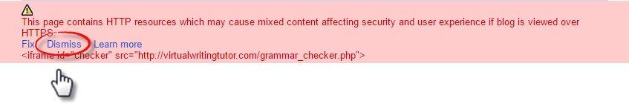
If you see this warning, make sure to click DISMISS. Otherwise, your iframe won’t work.

Add a B-block Vocabulary Checker
Copy the html code in the box below and paste it into the HTML editor of a new blog post. Give your blog post a title and publish it to see how the browser interprets the HTML code.
<style>
#vocabularychecker{
overflow-y: scroll;
overflow-x: hidden;
width: 700px;
height: 700px;
margin-top: 20px;
margin-bottom: 30px;
-moz-border-radius: 12px;
-webkit-border-radius: 12px;
border-radius: 12px;
-moz-box-shadow: 4px 4px 14px #000;
-webkit-box-shadow: 4px 4px 14px #000;
box-shadow: 4px 4px 14px #000;"
}
</style>
<br />
<center>Find field-related texts <a href="http://www.princetonreview.com/careers" target="_blank">here</a>.</center>
<center>
<iframe id="vocabularychecker" src="http://fieldrelated.com/vocabulary_checker.php">
<p>Your browser does not support iframes.</p></iframe>
</center>
<div class="separator" style="clear: both; text-align: center;">
<a href="http://fieldrelated.com"><img src="https://4.bp.blogspot.com/-J44Zjd42VS8/V6toWYSXoHI/AAAAAAAABwM/N3M0vel3LMQ7Xn5nr1laeM1u41RjltpGACLcB/s1600/logo.png" width="200" /></a></div>
<center>
FieldRelated.com is an <a href="http://FieldRelated.com" >online vocabulary checker</a> for English for Professional Purposes learners.</center>
<center>Find out how you can add digital literacy training to your CEGEP ESL course with a textbook from <a href="http://BokomaruPublications.com">Bokomaru Publications</a>.</center>

Note that this code inserts an iframe, a box showing another webpage within your webpage. To see the original webpage that the iframe is embedding in your blog post, go here: http://fieldrelated.com/vocabulary_checker.php
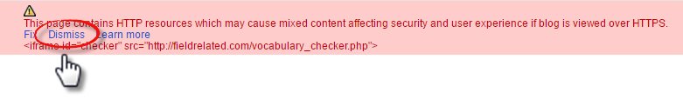
If you see this warning, make sure to click DISMISS. Otherwise, your iframe won’t work.

Add a Speech Recognition Enabled Pronunciation Checker
Copy the html code in the box below and paste it into the HTML editor of a new blog post. Give your blog post a title and publish it to see how the browser interprets the HTML code.
<meta property="og:image" content="https://2.bp.blogspot.com/-nFy5m4L8DkA/V7GyYu1FIrI/AAAAAAAAB0k/kgQ6fbrr_C4P0ZgszilAD6ueyRQP_YZIgCLcB/s1600/SpeakEnglishWell.jpg" />
<meta property="og:description"
content="Check your writing (and pronunciation) for errors with the Virtual Writing Tutor, an ESL grammar checker." />
<style>
#pronunciationchecker{
overflow-y: scroll;
overflow-x: hidden;
width: 700px;
height: 575px;
margin-top: 20px;
margin-bottom: 30px;
-moz-border-radius: 12px;
-webkit-border-radius: 12px;
border-radius: 12px;
-moz-box-shadow: 4px 4px 14px #000;
-webkit-box-shadow: 4px 4px 14px #000;
box-shadow: 4px 4px 14px #000;"
}
</style>
Use this speech recognition-enabled pronunciation checker to see if your pronunciation is comprehensible. If you are having difficulty being understood, type what you want to say into a <a href="http://actively-engaged-online.blogspot.ca/2015/06/how-do-you-pronounce-this.html" target="blank" >text-to-speech pronunciation helper</a> to get a clear model of the correct pronunciation of a word or phrase.
<center>
<iframe id="pronunciationchecker" src="https://virtualwritingtutor.com/speech/pronunciation-checker.html">
<p>
Your browser does not support iframes.</p>
</iframe>
</center>
<div class="separator" style="clear: both; text-align: center;">
</div>
<center>
The Virtual Writing Tutor is the <a href="https://virtualwritingtutor.com/index.php">best online grammar checker</a> for ESL learners because you can check your pronunciation and your grammar at the same time--for free!</center>
<center>
Find out how you can add digital literacy training to your CEGEP ESL course with a textbook from <a href="http://BokomaruPublications.com">Bokomaru Publications</a>.
</center>
<div class="separator" style="clear: both; text-align: center;">
<a href="http://bokomarupublications.com/" target="_blank"><img alt="Pronounce English well" border="0" src="https://2.bp.blogspot.com/-nFy5m4L8DkA/V7GyYu1FIrI/AAAAAAAAB0k/kgQ6fbrr_C4P0ZgszilAD6ueyRQP_YZIgCLcB/s1600/SpeakEnglishWell.jpg" title="Learn to speak English well with Bokomaru Publications" width="200" /></a></div>
Note that this code inserts an iframe, a box showing another webpage within your webpage. To see the original webpage that the iframe is embedding in your blog post, go here: http://virtualwritingtutor.com/speech/pronunciation-checker.html
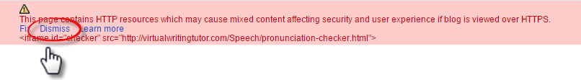
If you see this warning, make sure to click DISMISS. Otherwise, your iframe won’t work.

Add a Random Error Generator and Checker
Copy the html code in the box below and paste it into the HTML editor of a new blog post. Give your blog post a title and publish it to see how the browser interprets the HTML code.
<head>
<meta property=”og:description” content=”You don't really know English if don't you know how to correct your errors. Try this fun random error generator and checker. It is addictive!” />
</head>
<style>
#errorchecker{
style="overflow-y: scroll;
overflow-x: hidden;
width: 630px;
height: 500px;
margin-top: 20px;
margin-bottom: 30px;
-moz-border-radius: 12px;
-webkit-border-radius: 12px;
border-radius: 12px;
-moz-box-shadow: 4px 4px 14px #000;
-webkit-box-shadow: 4px 4px 14px #000;
box-shadow: 4px 4px 14px #000;"
}
</style>
<center>
<iframe id="errorchecker" src="http://virtualwritingtutor.com/random_error_checker.php">
<p>
Your browser does not support iframes.</p>
</iframe></center>
<div class="separator" style="clear: both; text-align: center;">
<a href="https://2.bp.blogspot.com/-oaUDjb3Yc7Q/V0RcHsKaSvI/AAAAAAAABqQ/-LljiHRWdDk4lx4VtntJKbSGzskmDAzCACLcB/s1600/random_error_checker.png" imageanchor="1" style="margin-left: 1em; margin-right: 1em;"><img border="0" height="168" src="https://2.bp.blogspot.com/-oaUDjb3Yc7Q/V0RcHsKaSvI/AAAAAAAABqQ/-LljiHRWdDk4lx4VtntJKbSGzskmDAzCACLcB/s320/random_error_checker.png" width="320" /></a></div>
<center>
The Virtual Writing Tutor is the <a href="http://VirtualWritingTutor.com/index.php">best online grammar checker</a>for ESL learners.</center>
<center>Find out how you can add digital literacy training to your CEGEP ESL course with a textbook from <a href="http://BokomaruPublications.com">Bokomaru Publications</a>.</center>
Note that this code inserts an iframe, a box showing another webpage within your webpage. To see the original webpage that the iframe is embedding in your blog post, go here: http://virtualwritingtutor.com/random_error_checker.php
If you see this warning, make sure to click DISMISS. Otherwise, your iframe won’t work.

Add a Text-to-Speech Pronunciation App
Copy the html code in the box below and paste it into the HTML editor of a new blog post. Give your blog post a title and publish it to see how the browser interprets the HTML code.
<html lang="en"> <center>
Are you unsure how to pronounce a word?
Use your browser's speech synthesis system to pronounce any word or phrase you type into the input box below.
<input id="mytext" style="font-size: 18pt; size: 50;" type="text" />

<button id="activate">Pronounce it</button></center>
</html>
<script>
function sayIt(query, language) {
var q = new SpeechSynthesisUtterance(query);
q.lang = language;
q.rate = 0.8;
speechSynthesis.speak(q);
}
function attach(elementId, event, functionName) {
var element = document.getElementById(elementId);
if (element.addEventListener) {
element.addEventListener(event, functionName, false);
} else if (element.attachEvent) {
element.attachEvent('on' + event, functionName);
} else {
element['on' + event] = functionName;
}
}
function interpret() {
sayIt(document.getElementById('mytext').value, 'en-US');
}
attach('activate', 'click', interpret);
</script>
<center>
<span style="font-size: xx-small;">Adapted code based on Jason Mayes' example here: <a href="http://codepen.io/anon/pen/xGXZaW">http://codepen.io/anon/pen/xGXZaW</a>
I checked this blog post for common grammar, punctuation and spelling errors using a <a href="http://virtualwritingtutor.com/" target="_blank">free online ESL grammar checker</a>.</span></center>
<div class="separator" style="clear: both; text-align: center;">
<a href="http://bokomarupublications.com/" target="_blank"><img alt="Actively Engaged Online book icon showing the cover and spiral binding" border="0" src="http://2.bp.blogspot.com/-g6bPmi1wdCc/VeWwPARANLI/AAAAAAAABbY/dELT2EVV-dQ/s1600/book_online.png" title="Actively Engaged Online: digital literacy for ESL" width="100" /></a></div>

Note that this code uses Javascript, a web programming language that interacts with the browser on the user’s computer. Some older browsers might not support this functionality.
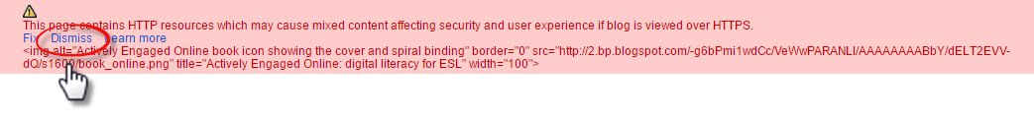If you see this warning, make sure to click DISMISS. Otherwise, your iframe won’t work.

Add an MP3 Voice Recorder App
Copy the html code in the box below and paste it into the HTML editor of a new blog post. Give your blog post a title and publish it to see how the browser interprets the HTML code.
<center><iframe src="http://vocaroo.com/?minimal" width="525" height="450" frameborder="0"></iframe>
Powered by <a href="http://vocaroo.com" title="Voice Recorder">Vocaroo Voice Recorder</a>
<a href="http://vocaroo.com" imageanchor="1" ><img border="0" src="https://3.bp.blogspot.com/-981Kk7DOyro/V63Fp9fPIoI/AAAAAAAABxo/wd8izgJijKg4Uhls-IXhwqZbtRxCMYu-gCLcB/s200/vocaroo_recorder.png" width="100" height="52" /></a></center>

Vocaroo uses Flash, a programming language that is being quickly replaced by HTML5. This iframe might not work on Apple phones.
Note that this code inserts an iframe, a box showing another webpage within your webpage. To see the original webpage that the iframe is embedding in your blog post, go here: http://vocaroo.com.
As you can see from the URL, it not encrypted (http instead of https), so make sure to dismiss the warning from Blogger. If you click “fix,” this resource will not work and you will have to copy + paste the code above again.
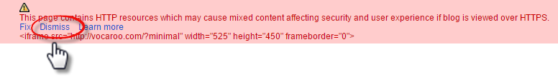
If you see this warning, make sure to click DISMISS. Otherwise, your iframe won’t work.

Embed a Video from YouTube
Copy the html code in the box below and paste it into the HTML editor of a new blog post. Give your blog post a title and publish it to see how the browser interprets the HTML code.
<center>
<iframe width="420" height="315" src="https://www.youtube.com/embed/wMFHPG2uqcY?rel=0" frameborder="0" allowfullscreen></iframe>
</center>

Note that this code inserts an iframe, a box showing content from another website. To see the original content that the iframe is embedding in your blog post, go here: https://www.youtube.com/watch?v=wMFHPG2uqcY
To embed other videos, find the video you want to embed on YouTube, click “Share” then “Embed” then copy (Ctrl +C) the iframe code in the box. Use
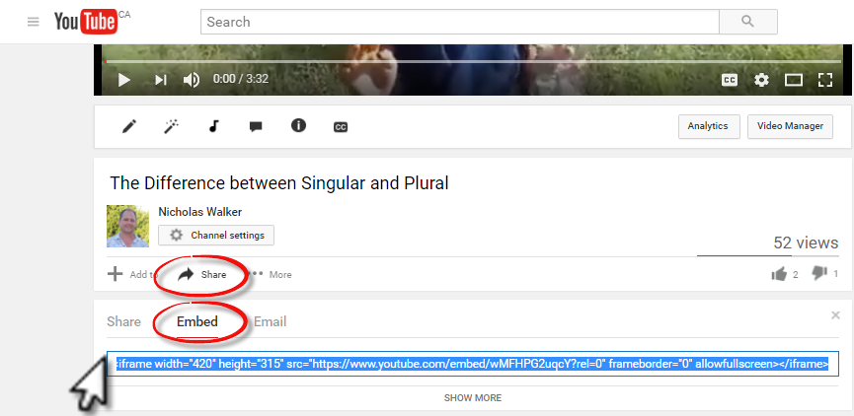

Add Copyright Free Images from WikiMedia Commons
Some teachers believe that some of their students are “visual learners” while another subset of the group learns best from kinesthetic or aural learning activities. Decades of research into learning styles have failed to validate this belief. To illustrate why, the brain receives 11 million units of sensory information at any one moment. Ten million of those units are from the eyes. Consequently, all normally developing learners have an enormous visual cortex for processing that information and will benefit from receiving images paired with linguistic input. Therefore, you can improve learning outcomes by including relevant images in your lessons and blogposts. But where can we get copyright-free images? Navigate to https://commons.wikimedia.org.
- Use the search box in the top right to search for Collège Ahuntsic.
- Click on “Use this file on the web”.
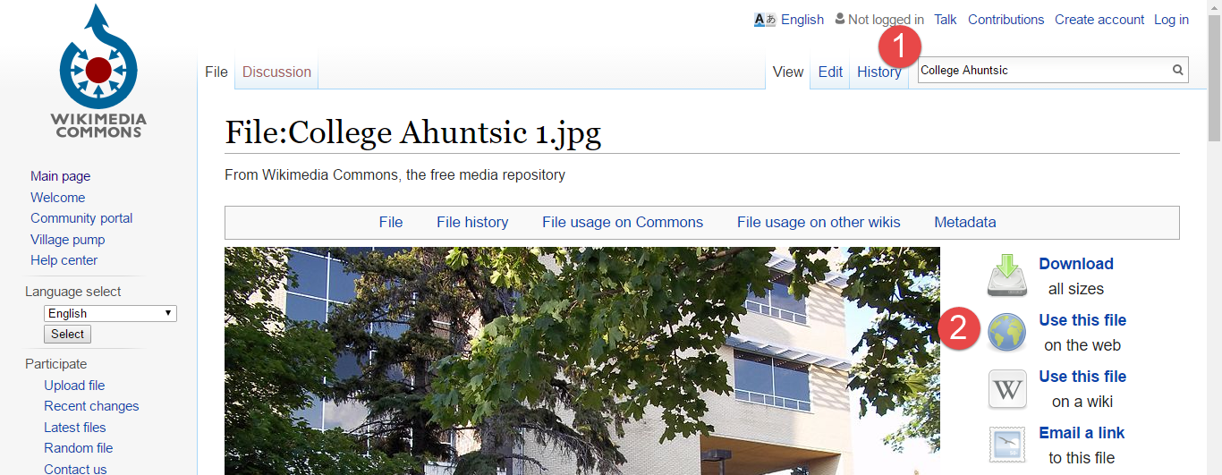

- Copy the HTML code for the size of image you want.
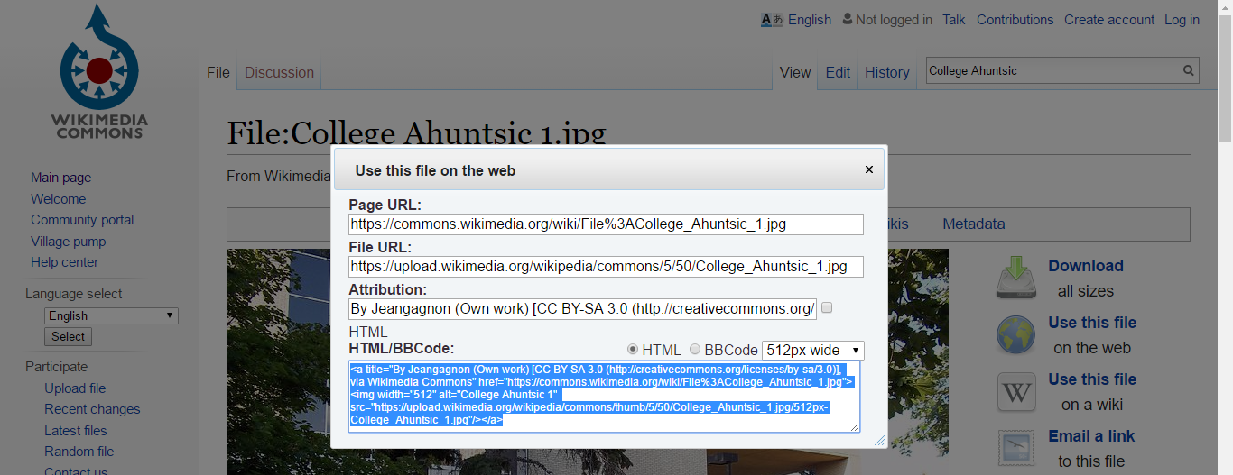
- Paste it into the HTML mode of a blog post, and publish it. Hover your mouse over the image. The copyright holder’s attribution will show up as a “title,” and you will have satisfied the copyright requirements.

Get your own Domain Name
Instead of having a blog with a URL like Actively-Engaged-Online.Blogspot.com, imagine having your own domain name of your own invention with a .com or other extension, like ESL-Excellence.com or something. It is easy and affordable.
Change this: yourblog.blogspot.com
To this: www.YourWebsite.com
To learn how to do this, copy the html code in the box below and paste it into the HTML editor of a new blog post. Give your blog post a title and publish it.
Instead of having a blog with a URL like&nbsp;<a href="http://actively-engaged-online.blogspot.com/">Actively-Engaged-Online.Blogspot.com</a>, imagine having your own domain name with a .com or other extension of your own invention, like ESL-Excellence.com or something. It is easy and affordable.
<b>
</b> <div>
<div style="text-align: center;">
<b>Change this:&nbsp;</b><strike>yourblog.Blogspot.com</strike></div>
<div style="text-align: center;">
<b>
</b></div>
<div style="text-align: center;">
<b>To this: </b>www.YourWebsite.com</div>
<h2 style="clear: both; text-align: left;">
Step 1: Navigate to&nbsp;<a href="https://hover.com/CaW3Pfhm">Hover</a>&nbsp;</h2>
<div class="separator" style="clear: both; text-align: left;">
Hover is a domain registrar that can find and register domain names with a variety of extensions.&nbsp;</div>
<div class="separator" style="clear: both; text-align: left;">

</div>
<div class="separator" style="clear: both; text-align: center;">
<a href="https://3.bp.blogspot.com/-khAwNRhGYgk/V630hd7HLsI/AAAAAAAAByI/iW56S3W_tBM4Rbu3sjVb861a3-qOMx7dgCLcB/s1600/hover1.png" imageanchor="1" style="margin-left: 1em; margin-right: 1em;"><img border="0" height="307" src="https://3.bp.blogspot.com/-khAwNRhGYgk/V630hd7HLsI/AAAAAAAAByI/iW56S3W_tBM4Rbu3sjVb861a3-qOMx7dgCLcB/s640/hover1.png" width="640" /></a></div>
<div class="separator" style="clear: both; text-align: left;">

</div>
<h2>
&nbsp;Step 2: Think of a Domain Name you would Like</h2>
Simply, type in a domain name you might like for yourself, and click search, like this. For example, I would like people to find my blog by typing in "www.ESL-excellence.com" so I typed in "ESL-excellence.com" and clicked the search icon.

<div class="separator" style="clear: both; text-align: center;">
<a href="https://1.bp.blogspot.com/-kbsYZq6I1iY/V630hZqsMkI/AAAAAAAAByM/AoboJ5ORh4cZtsRxSYnCTTJ9WP2uUJLiwCLcB/s1600/hover2.png" imageanchor="1" style="margin-left: 1em; margin-right: 1em;"><img border="0" height="308" src="https://1.bp.blogspot.com/-kbsYZq6I1iY/V630hZqsMkI/AAAAAAAAByM/AoboJ5ORh4cZtsRxSYnCTTJ9WP2uUJLiwCLcB/s640/hover2.png" width="640" /></a></div>

<h2>
Step 3: Register the Domain Name</h2>
I was lucky and the domain name I wanted was available. To buy it, all I have to do is click on the plus sign and pay.
<div>

</div>
<div class="separator" style="clear: both; text-align: center;">
<a href="https://1.bp.blogspot.com/-mW8NHAil4EM/V630hEdJvVI/AAAAAAAAByE/XGznmTGA8MMZrY8AAOTTQ4P7bVp7sRcrACLcB/s1600/hover3.png" imageanchor="1" style="margin-left: 1em; margin-right: 1em;"><img border="0" height="308" src="https://1.bp.blogspot.com/-mW8NHAil4EM/V630hEdJvVI/AAAAAAAAByE/XGznmTGA8MMZrY8AAOTTQ4P7bVp7sRcrACLcB/s640/hover3.png" width="640" /></a></div>

<h2>
Step 4: Link the Domain Name to Your Blog</h2>
<div class="separator" style="clear: both; text-align: left;">
After buying your domain name, the next step is to make it point to your Blogger blog. Navigate to your blogger account and click on your blog. Then, click on settings.&nbsp;</div>
<div class="separator" style="clear: both; text-align: left;">

</div>
<div class="separator" style="clear: both; text-align: center;">
<a href="https://2.bp.blogspot.com/-OCk62W_VMjU/V630hqyujOI/AAAAAAAAByQ/z-4felTnzxUVUkekR-B2-l3KmfJLje_ugCLcB/s1600/hover4.png" imageanchor="1" style="margin-left: 1em; margin-right: 1em;"><img border="0" height="290" src="https://2.bp.blogspot.com/-OCk62W_VMjU/V630hqyujOI/AAAAAAAAByQ/z-4felTnzxUVUkekR-B2-l3KmfJLje_ugCLcB/s640/hover4.png" width="640" /></a></div>

<h2>
Step 5: Navigate to Settings</h2>
<div class="separator" style="clear: both;">
After buying your domain name, the next step is to make it point to your Blogger blog. Navigate to your blogger account and click on your blog. Then, click on settings.&nbsp;</div>
<div class="separator" style="clear: both; text-align: center;">
<a href="https://1.bp.blogspot.com/-dcXKMCm8XTo/V630h8EqyZI/AAAAAAAAByU/BIruO6-xjdwK-1H7hPZj_gJiD1gpGxzXwCLcB/s1600/hover5.png" imageanchor="1" style="margin-left: 1em; margin-right: 1em;"><img border="0" height="350" src="https://1.bp.blogspot.com/-dcXKMCm8XTo/V630h8EqyZI/AAAAAAAAByU/BIruO6-xjdwK-1H7hPZj_gJiD1gpGxzXwCLcB/s640/hover5.png" width="640" /></a></div>
<h2>
Step 6: Enter Your New Domain Name</h2>
<div class="separator" style="clear: both;">
Now, simply enter your domain name into the field on Blogger, and click save.</div>
<div class="separator" style="clear: both;">

</div>
<div class="separator" style="clear: both; text-align: center;">
<a href="https://1.bp.blogspot.com/-zpQlCUo5gyQ/V630h7MUoUI/AAAAAAAAByY/QAJ8KefXsq4Cih0WN3ShTv5boE3lvo9OACLcB/s1600/hover6.png" imageanchor="1" style="margin-left: 1em; margin-right: 1em;"><img border="0" height="410" src="https://1.bp.blogspot.com/-zpQlCUo5gyQ/V630h7MUoUI/AAAAAAAAByY/QAJ8KefXsq4Cih0WN3ShTv5boE3lvo9OACLcB/s640/hover6.png" width="640" /></a></div>

<h2>
Step 7: Enter Blogger's Details on Hover</h2>
Blogger will give you CNAME and other details associated with your blog. Copy the information exactly into the appropriate fields on Hover. Hover has people who can help you with this step if you get stuck. It's not as difficult as you might think. Once your info has been entered, your readers will be able to navigate to your blog using your www address.

<div class="separator" style="clear: both; text-align: center;">
<a href="https://2.bp.blogspot.com/-4kKFADBbflA/V636wzFJ4-I/AAAAAAAABy0/7cUTXysPJEoGCwhpNpxow3Uq1BHlFxwIACLcB/s1600/hover7.png" imageanchor="1" style="margin-left: 1em; margin-right: 1em;"><img border="0" height="308" src="https://2.bp.blogspot.com/-4kKFADBbflA/V636wzFJ4-I/AAAAAAAABy0/7cUTXysPJEoGCwhpNpxow3Uq1BHlFxwIACLcB/s640/hover7.png" width="640" /></a></div>

<div class="MsoNormal">
<!--[if gte vml 1]><v:shape
id="Picture_x0020_201" o:spid="_x0000_i1025" type="#_x0000_t75" style='width:5in;
height:232.8pt;visibility:visible;mso-wrap-style:square'> <v:imagedata src="file:///C:\Users\Nicholas\AppData\Local\Temp\msohtmlclip1\01\clip_image011.png"
o:title=""/> </v:shape><![endif]--><!--[if !vml]--><!--[endif]--><span lang="EN-CA"><o:p></o:p></span></div>
</div>

Resources for Learning More about Blogging and HTML
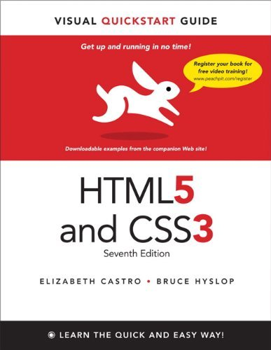
Here are just a few resources you should know about if you want to learn more about HTML. CTRL + click on the links provided to open a browser and navigate directly to the resource.
- HTML Visual QuickStart Guide by Elizabeth Castro and Bruce Hyslop
Want to learn how to build Web sites fast? This best-selling guide’s visual format and step-by-step, task-based instructions will have you up and running with HTML5 and CSS3 in no time. This Seventh Edition is a major revision, with approximately 125 pages added and substantial updates to (or complete rewrites of) nearly every page from the preceding edition. Authors Elizabeth Castro and Bruce Hyslop use clear instructions, friendly prose, and real-world code samples to teach you HTML and CSS
- WC3 Schools HTML Tutorial
This is a very useful website for learning HTML. It has definitions, lessons, quizzes, and a feature that allows you to try out code to see what it does. It is ad supported, so be sure to click on a few ads to support this wonderful website.
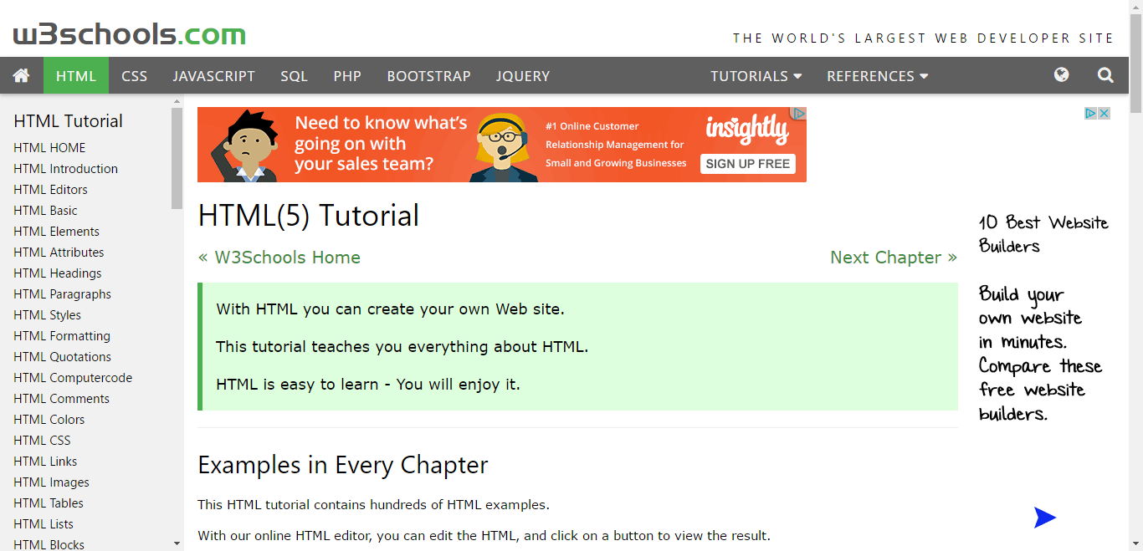
- Google Search
This may seem obvious, but simply typing in a tag or a question about HTML like “How do I…?” or “What is…?” will return a great number of tutorials, videos, and links to forums where others have asked the same question.
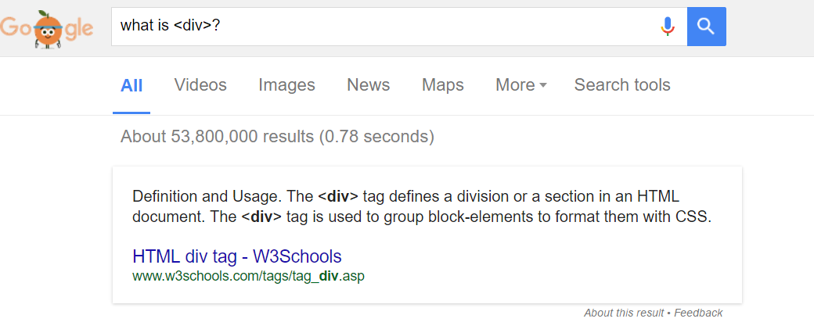
- Actively Engaged Online, by Nicholas Walker
They say that to teach is to learn twice. Teach digital literacy as a part of a second language course and you will find that you will learn ten times faster. To help you get started, order Actively Engaged Online for your students and you will have all of the resources and assessments needed to successful teach an ESL course with a digital literacy focus for low or high intermediates.
Actively Engaged Online was developed to make program-related ESL courses at the college level more relevant to the modern workplace and academic fields by incorporating digital literacy training into reading, writing, listening and speaking tasks.
Different from other textbooks with their separate volumes for grammar and skills, Actively Engaged integrates reading and listening with grammar lessons, card games, information gaps, simulations, and a multi-week hypertext narrative writing project. During the course, language structures are taught and practiced step-by-step for meaningful use in complex speaking and writing tasks.
Students love the liveliness and cohesiveness of the lessons. Teachers love how manageable their workload becomes with the complete set of online evaluations and integration of the Virtual Writing Tutor to provide instant corrective feedback on writing errors. In short, Actively Engaged Online is a pedagogically sound alternative to the formulaic course books on the market.

